Task 1:

Create a Directory with the Name Linux Practice.

3 min

Task2:

Change to the directory

2 min

Task 3:

Create a file names TestFile1.txt and add the content to it.

5 min

Task 4:

Create a Folder named Dummy and try to delete it.

5 min.

Task 5:

Plz check the working directory (Hint : pwd)

2 min

Task 6:

How do you check all the files and directories in the directory you are in?

3 min

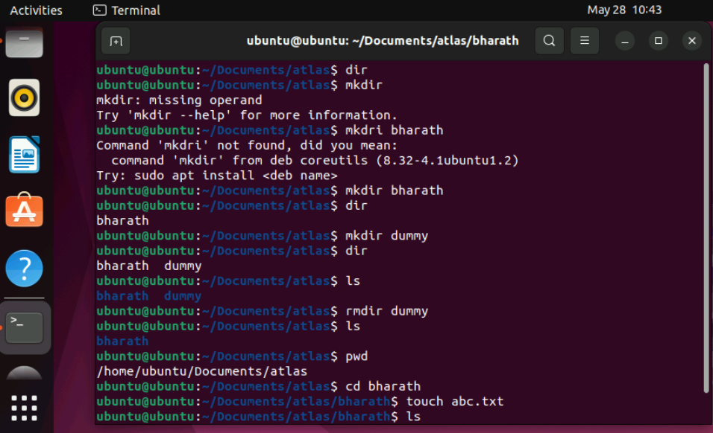

Task 7:

Create five files named TestFile2.txt.. TestFile3.txt… and so on till TestFile6.txt

5min

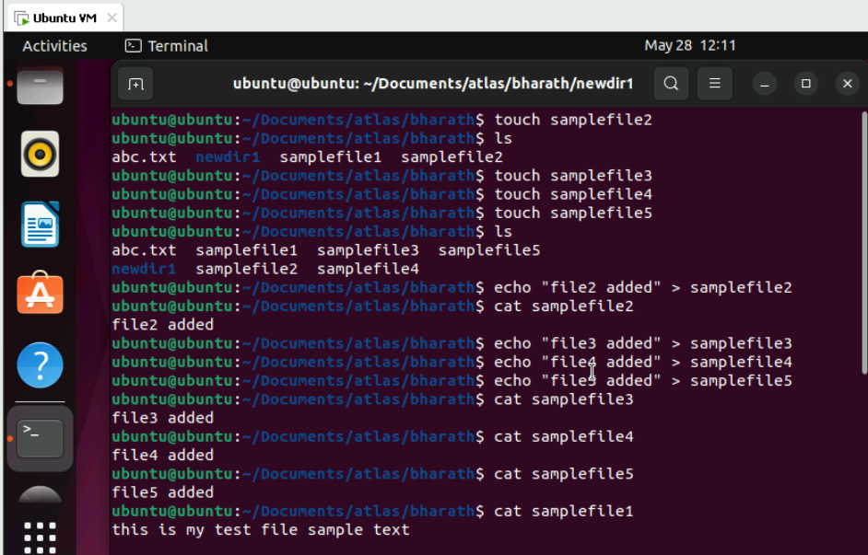

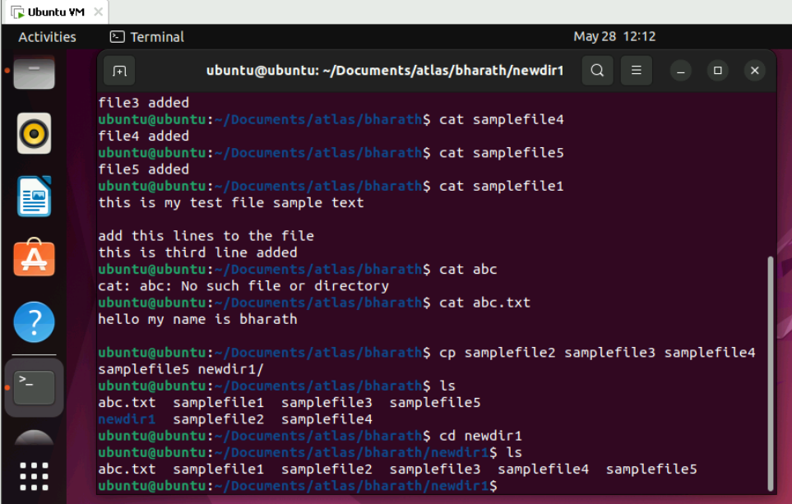

11.50 to 11.55

Plz raise ur hand once done

Task 8:

Copy all files from Dir 1 ti Dir 2

2 min 11.55 to 11.57

Task 9:

Move all files from Dir 2 to Dir 3 (finally ur Dir 2 should be empty)

3 min  11.58 to 12.00

Task 10:

Can you plz show me the diff between **rm** and **rmdir** commands with screen shots ?

12.01 to 12.05

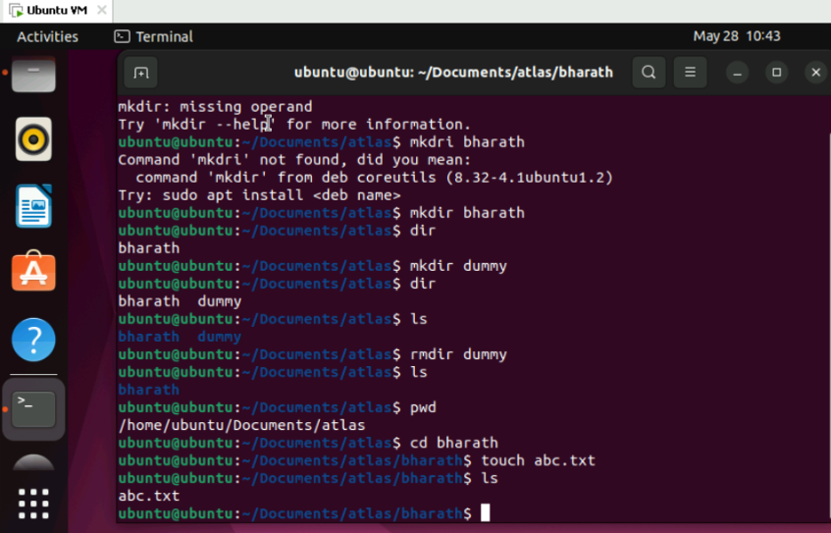

Ok now open Lorem Ipsum in your browser

<https://www.lipsum.com/>  u can use this link for random text..

Task 11:

Now use specifically use cat command to create a file

And add the dummy text of 2 to 3 paragraphs from the above link Lorem Ipsum.

5 min  12.08 to 12.13

Task 12:

How to get only the top part of your file..

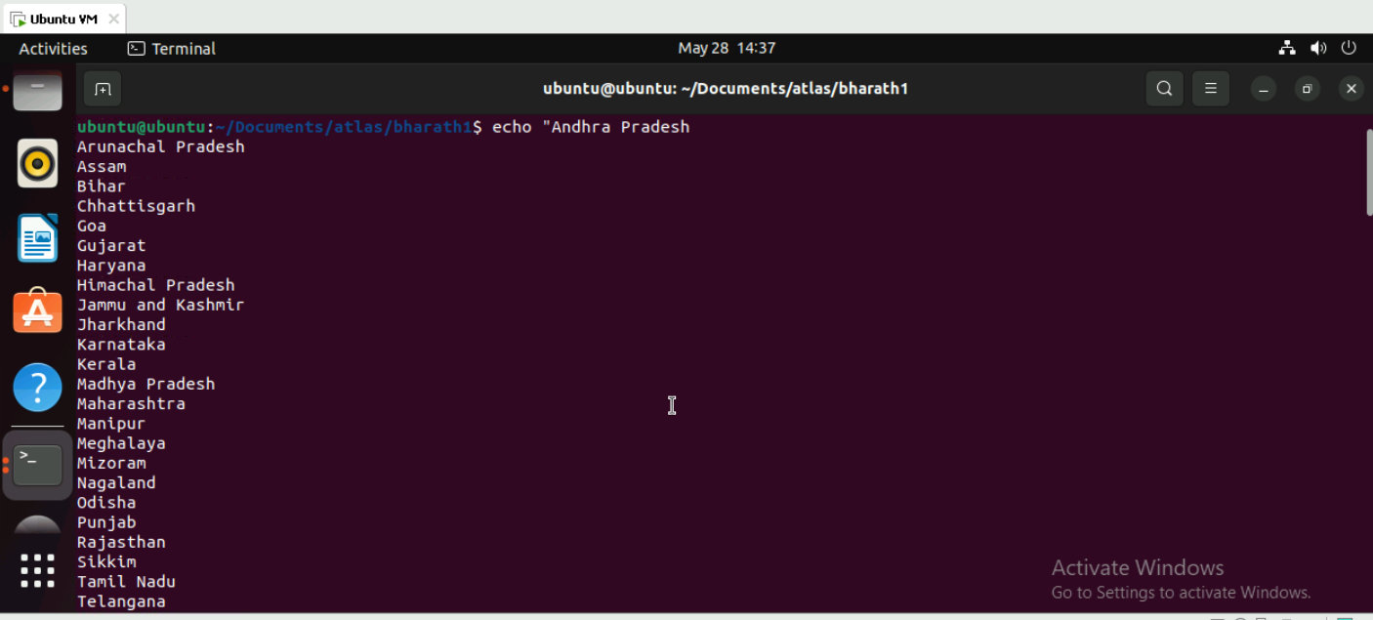

Hint: use head

5 min 12.14 to 12.18

Task 13:

How to get only the last part of your file

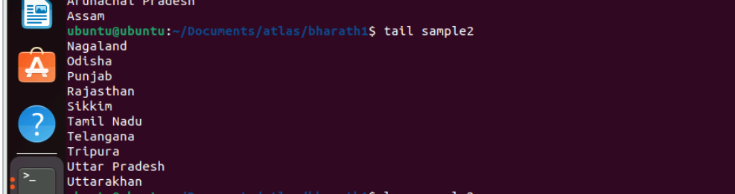

Hint: use tail

12.19 to 12.24

Task 14:

Plz add dummy text of 5 to 6 pages in to the same file

And

Now show the file in page by page

Hint : use less command

12.25 to 12.35 10 min

Task 15:

Use more command on the above file and find out the diff between less command and more command.

12.36 to 12.40 5 min

What is e in echo command..?

The e in the echo command is an option that enables the interpretation of backslash escape sequences. These sequences allow you to insert special characters and formatting into the output.

Task 16:

Can you use echo command with -e and see the diff.. Also take a ss and paste .

12.44 to 12.48 4 min

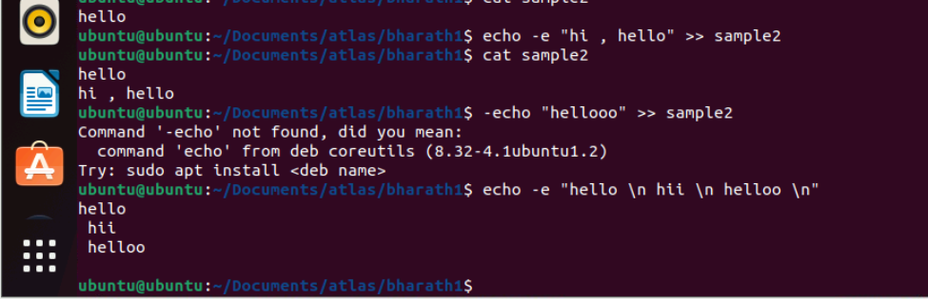

Task 17:

What is diff between ls and ls -l command .. ss plz

12.49 to 12.55.

**ls command:**

* Shows basic file/directory listing
* Displays names only
* Horizontal listing format
* Simple output.

**ls -l command:**

* Shows detailed listing
* Displays permissions
* Shows file size
* Shows owner/group
* Shows last modified date/time
* Shows file/directory names
* Vertical listing format.

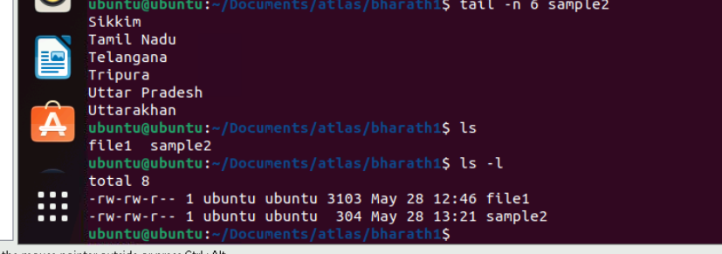

Task 18:

Create  a file using **touch** command , **cat** command and **echo** command and take ss (screen shot)..

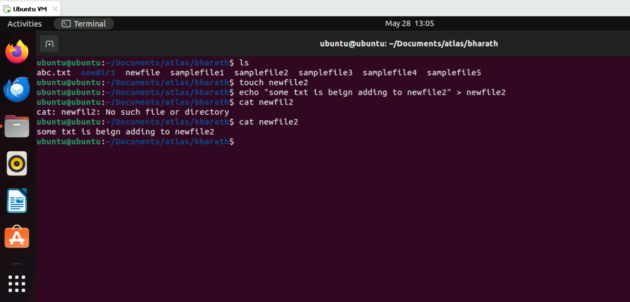

Also write the difference between touch , cat and echo commands.

12.55 to 1pm

TOUCH Command:

* Creates empty files
* Updates timestamps of existing files
* Doesn't modify file content

CAT Command:

* Displays file content
* Concatenates multiple files
* Can create files with content

ECHO Command:

* Prints text to screen
* Can write text to file

Task 19:

Can you guys try to display the calendar by using a command..

Hint: use cal

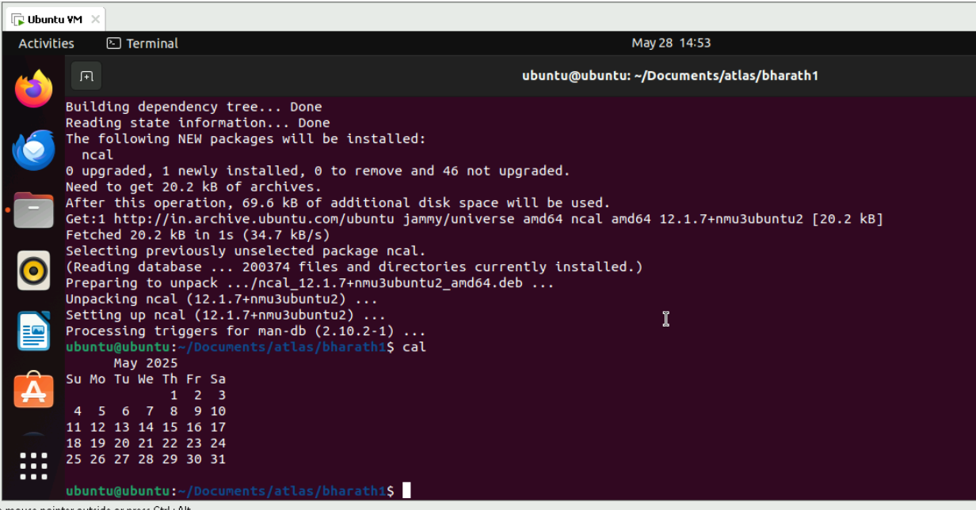

2 min 14.45 to 14.47

Task 20:

Can you go back to 1 directory .. at a time  whats the command

Cd ..



2 min 14.48 to 14.49

Task 21:

How to know whose user u are working on ?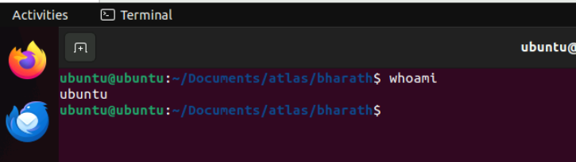

Hint: use whoami command

2 min 14.50 to 14.52

Task 22:

Try to find out who is peeping into your system..

Use users, who and w commands with ss

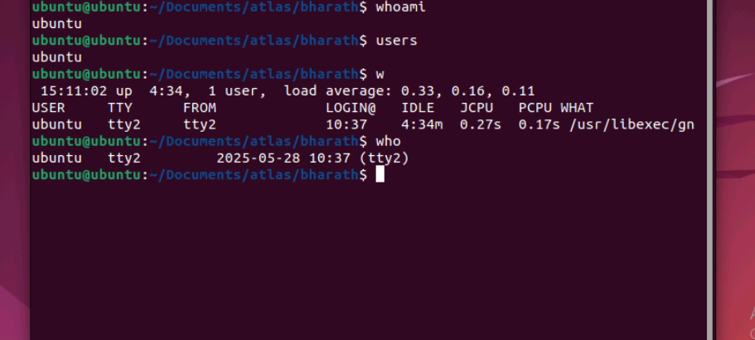

15.06 to 15.16

Task 23:

Can you guys try to check how much disk space is consumed..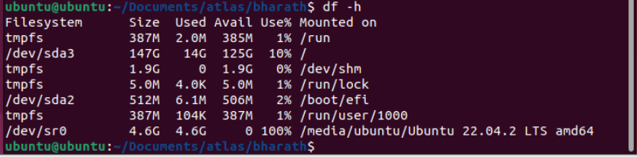

Hint : use df -h

15.17 to 15.20

Task 24:

Can you plz try using the below commands

|  |  |
| --- | --- |
| **Prefix** | **Description** |
| **-** | **Regular file**, such as an ASCII text file, binary executable, or hard link. |
| **b** | **Block special file**. Block input/output device file such as a physical hard drive. |
| **c** | **Character special file**. Raw input/output device file such as a physical hard drive. |
| **d** | **Directory** which contains a listing of other files and directories. |
| **l** | **Symbolic link file**. Links on any regular file. |
| **p** | **Named pipe**. A mechanism for interprocess communications. |
| **s** | **Socket** which is used for interprocess communication. |

Task 25:

Find the list pf all files ending with .txt

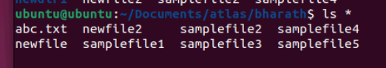

Hint : use * in ls

2 min 15.32 to 15.34

Task 26:

In Linux all the hidden files starts with . (period)

How to check all the hidden files in Linux..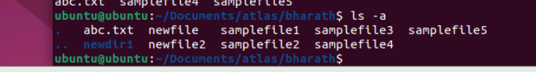

Hint : use  ls -a

15.35 to 15.37

Task 27:

What is the difference between . and .. in linux

Line 1 line for each

. (Single dot): Represents the current directory you are in (present working directory)

.. (Double dot): Represents the parent directory (one level up from your current directory)

2 min  15.38 to 15.40

Task 28:

Can you create a file using vi editor and show the details in ss

Hint:

 Esc is for come out of the edit mode

Press two keys Shift &plus; ZZ together to come out of the file completely

* I - to insert

To move inside the file

* **l** key to move to the right side.
* **h** key to move to the left side.
* **k** key to move upside in the file.
* **j** key to move downside in the file.

Task 29:

How to find the no of words in the file

Hint: use wc

15.44 to 15.48

Here is the detail of all the four columns of wc command  −

* **First Column** − Represents the total number of lines in the file.
* **Second Column** − Represents the total number of words in the file.
* **Third Column** − Represents the total number of bytes in the file. This is the actual size of the file.
* **Fourth Column** − Represents the file name.

Task 30:

What is the use of cat -b myfilename.txt command?

15.49 tpo 15.52

Task 31:

Can I use the wc with 2 or more files?

Wc file1 file2 file3

15.53 to 15.58

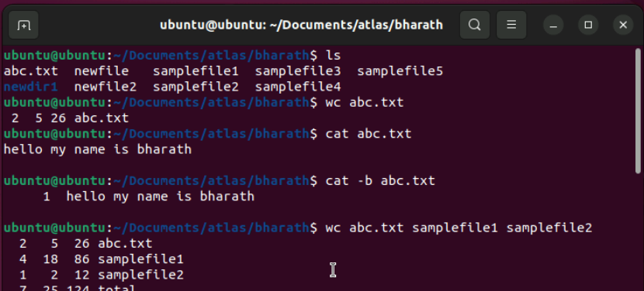

Task 32:

How to copy content of one file to another file

Hint: use cp:

15.59 to 16.05

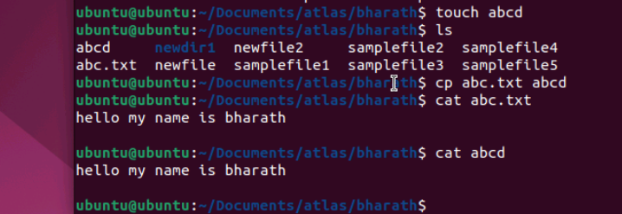

Task 33:

Now I want to rename my file with MYFILENEW can i do that if so how ?

Hint use : mv

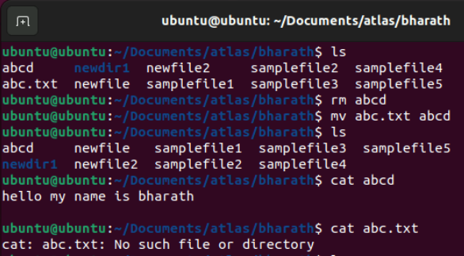

Task 34:

Can i remove or delete multiple files in linux..? How?

16.06 to 16.08

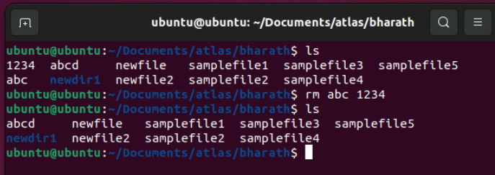

Task 35:

In directory / slash is root  …  can you try cd / what is it doing?

Ss plz

16.09 to 16.11



Linux directory structure: plz have a reading and try to remember..

|  |  |
| --- | --- |
| **Directory** | **Description** |
| **/bin** | important binary applications |
| **/boot** | boot configuration files, kernels, and other files needed at boot time. |
| **/dev** | System device files. |
| **/etc** | configuration files, startup scripts, etc. |
| **/home** | List of home directories for different users |
| **/lib** | system libraries, shared libraries |
| **/lost+found** | a lost+found system for files that exist under the root (/) directory |
| **/media** | automatically mounted (loaded) partitions on your hard drive and removable media such as CDs, digital cameras, etc. |
| **/mnt** | manually mounted filesystems on your hard drive |
| **/opt** | 3rd part applications to be installed |
| **/proc** | Maintains information about the state of the system, including currently running processes. |
| **/root** | root user's home directory. |
| **/sbin** | important system binaries |
| **/srv** | contain files that are served to other systems |
| **/sys** | system files |
| **/tmp** | temporary files |
| **/usr** | applications and files that are mostly available for all users to access |
| **/var** | variable files such as logs and databases |

Task 36:

What is the way go go to home directory ?



Hint : use cd ~

16.12 to 16.15

16.15 to 16.30 Tea Break

Task 37:

If i want to move to different users home directory

Hint : use ~username

16.30 to 16.35